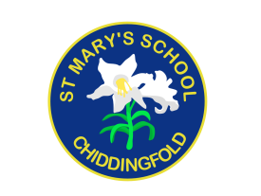
St Mary’s Church of England Primary School
an academy in the Good Shepherd Trust
Petworth Road, Chiddingfold, Surrey, GU8 4UF

Headteacher: Mrs Sheila Buckley

(t) 01428 683115, (e) admin2@stmarys-godalming.surrey.sch.uk (w) www.stmaryschidd.org
Respect, Wisdom, Hope, Community
5th December 2022

Dear Parents/Carers,

Y5 trip to Winchester Science Centre and Planetarium

On Wednesday 15th March 2023, we will be taking both Year 5 classes to Winchester Planetarium and Science Centre to support our learning around the topic of Space.

The total cost of the trip will be £22.73 this includes the cost of the coach, entry fee and an exciting workshop linking to our spring term topic. We invite you to make a voluntary contribution towards this trip, which can be paid online by Friday 13th January 2023. If you are unable to contribute for any reason, please speak to Mrs Buckley in confidence. If we do not receive enough contributions towards the cost of the trip, we will inevitably have to cancel. As this is such an exciting opportunity to enhance the curriculum, this course of action would be a great shame. Please note that payment on Scopay will act as your consent for your child to take part.

To help the children have an enjoyable day, we thought we should remind you of some of the things they will need:
- A packed lunch with a drink is required in a backpack (no glass bottles, fizzy drinks or any food containing nuts please).
- Children will be required to wear normal school uniform and must have a waterproof coat.
- Children are allowed to bring a maximum £5 cash with them as we will have an opportunity to look around the souvenir shop.

We will be travelling by coach, leaving promptly at 8.30am and will be back at St. Mary's, traffic permitting, at approximately 3.30pm. Please bear with us if we are a little late returning and ensure you make any necessary arrangements in advance in case the coach is delayed. If we anticipate a much later return, you will be notified by text message.

Yours sincerely,
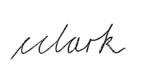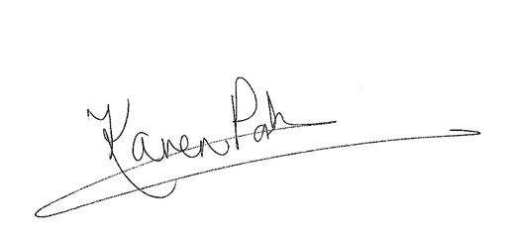
Christie Clark Karen Porter
Year 5C Class Teacher Year 5P Class Teacher

