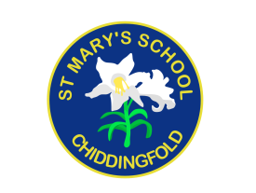
St Mary’s Church of England Primary School
an academy in the Good Shepherd Trust
Petworth Road, Chiddingfold, Surrey, GU8 4UF

Headteacher: Mrs Sheila Buckley

(t) 01428 683115, (e) admin2@stmarys-godalming.surrey.sch.uk (w) www.stmaryschidd.org
Respect, Wisdom, Hope, Community
7th December 2022

Dear Parents/Carers

Year 1 visit to Pierrepont Farm on 9th March 2023

Our topic next term is Food and Farming. We would like to take the children to Pierrepont Farm in Frensham to help us understand more about where our food comes from and learn how it gets from farm to plate. We will be finding out all about dairy cows and how we get our milk.

The cost of the trip is £19.10 per person, which covers the cost of the coach and entry. We invite you to make a voluntary contribution towards this trip, which can be paid in Scopay by Friday 20th January 2023. If you are unable to contribute for any reason, please speak to Mrs Buckley in confidence. If we do not receive enough contributions towards the cost of the trip, we will inevitably have to cancel. Please note, payment in Scopay will act as your consent for your child to go on this trip.

To help the children have an enjoyable day we thought we should remind you of some of the things they will need:
- A packed lunch (no glass bottles, nuts or fizzy drinks please) in a small rucksack (as children will need to carry their belongings with them for the duration of the tour).
- Children should wear PE kit. Please make sure your child wears a suitable coat and suitable footwear. Please send your child with wellies for changing into.

We shall be travelling by coach leaving at 9.00am and will be back at St. Mary's, traffic permitting, at approximately 3.00 p.m. Please bear with us if we are late or perhaps make any necessary arrangements in advance in case the coach is delayed. If we anticipate a late return, you will be notified by text message.

If parents are able to help by supervising a small group on the trip can you please let me know.

Yours sincerely
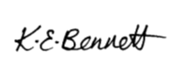
Kirsten Bennett
Class Teacher

