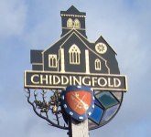
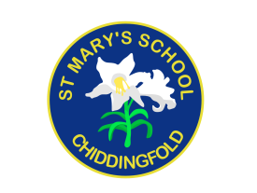
St Mary’s Church of England Primary School
an academy in the Good Shepherd Trust
Petworth Road, Chiddingfold, Surrey, GU8 4UF

Head teacher: Mrs Sheila Buckley

(t) 01428 683115, (f) 01428 682294, (e) admin2@stmarys-godalming.surrey.sch.uk (w) www.stmaryschidd.org
Respect, Wisdom, Hope, Community

6th October 2022

Dear Parents/Carers,

Whole school trip to the Nativity at Wintershall – Thursday 15th December 2022

We are delighted to inform you that, as part of our Advent celebrations this year, we intend to take all children from St Mary’s to a very special Nativity performance being held at the Wintershall Estate in Bramley this December.

The Wintershall Nativity is both dramatic and intimate, beginning in the open air with the shepherds in the fields, huddled around their fires. We will then take our seats in the atmospheric Holly Barn Theatre, where the story of Jesus’ birth will unfold, with real sheep and donkeys looking on! The captivating performance will be accompanied by a workshop where the children will be able to explore the meaning of Christmas in greater depth.

This trip, which promises to be an unforgettable experience, is being offered to all children at the school for just £2 per head (including transport and performance ticket), thanks to the generous support of the Wintershall Estate and the St Mary’s Parent Teacher Association. It is a truly unique, special way to celebrate Advent and we are looking forward to sharing it with the children. We invite you to make a voluntary contribution towards this trip, which can be paid on-line via Scopay by Friday 18th November 2022. If you are unable to contribute for any reason, please speak to Mrs Buckley in confidence. Please note that payment in Scopay will act as your consent for your child to take part.

On the day
We will travel to the Wintershall Estate by coach, leaving school at 10am to give us time to get there and settled in time for the start of the Nativity. After the performance, we will enjoy a picnic lunch before returning to school at approximately 2pm. The children will be ready for collection at the usual pick up time.

Your child will need:

- school PE kit (school sweatshirt or hoodie, joggers, wellies or suitable outdoor shoes), a warm coat, hat, scarf and gloves (we will be outdoors for some of the time)
- a small rucksack
- a packed lunch (no products containing nuts or fizzy drinks, please)*
- a water bottle
*all pupils in Year R, 1 & 2 and free school meal pupils in KS2 are entitled to a school made packed lunch. This will be:

Ham or Cheese roll
Carrot & cucumber crudities
Shortbread biscuit
Apple.

If you DO require this lunch, please complete the below form by 1st December letting us know your choice of filling.

https://forms.office.com/Pages/ResponsePage.aspx?id=VRXHn1nppkqDDPJVBfxa7pdvzokkYcpCqkpagMWh4lVUMjQwR0JMUFQ0WExaUlBWUkpROVNESkUzVC4u

If we do not hear from you, your child WILL NOT get a school made packed lunch and your child will need to provide their own.

Yours sincerely,

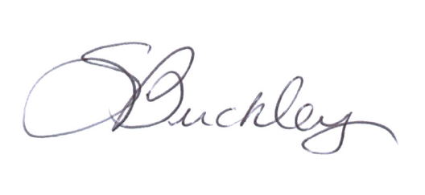

Mrs Sheila Buckley
Head teacher

