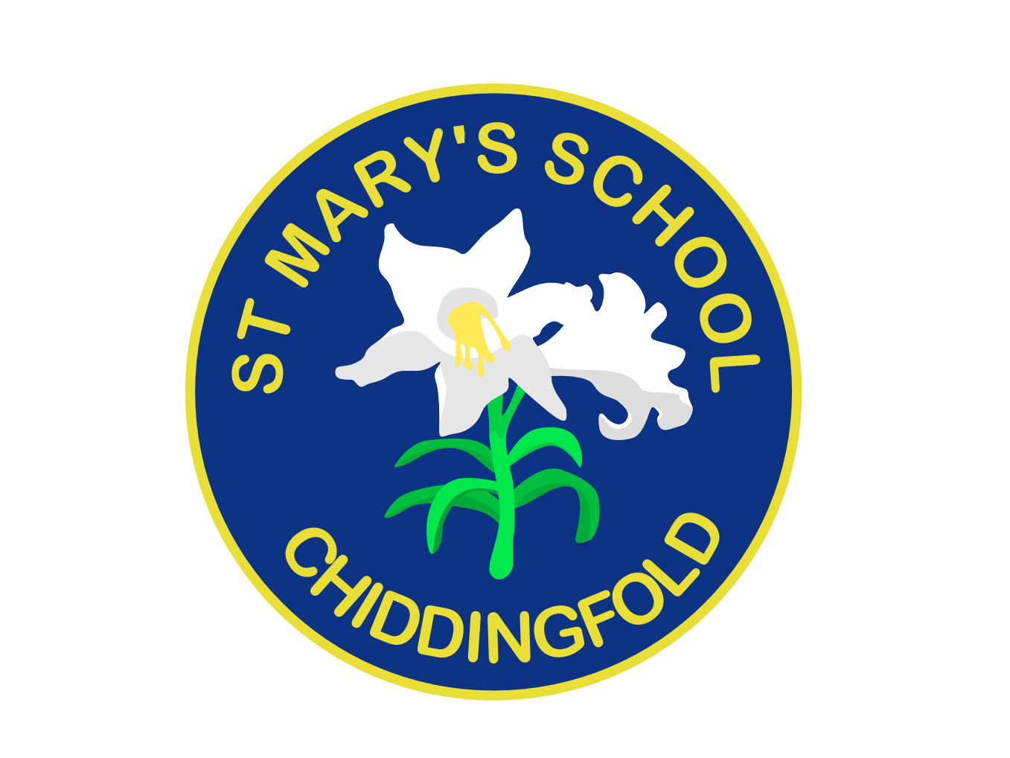
St Mary’s Church of England
Primary School

Whole School
Food Policy

September 2022
(To be reviewed September 2024)

St. Mary’s Primary School is a Church school where our Christian faith lies at the heart of our ethos, creating and nurturing a compassionate and secure family community. We provide a caring school environment which challenges, motivates and stimulates each child, whilst fostering qualities of excellence.

St. Mary’s Primary School is a 240-place school for children aged from 4 to 11 years. The school has seven classes organised as mixed ability classes across the seven year groups.

Introduction:
In our school we are committed to giving all our pupils consistent messages about all aspects of health to help them understand the impact of particular behaviours and encourage them to take responsibility for the choices they make. This includes promoting healthy eating patterns for everyone at school.

Our belief is that a balanced healthy, nutritious diet is important for the development of a child’s physical state, as well as for their intellectual abilities. Feeding the body with the proper nutrients helps fuel the mind to be more receptive to learning new skills (feed the body, fuel the mind).

Rationale:
St Mary’s strives to be a healthy school. We have a Bronze award from Surrey Healthy Schools. It is important that we consider all elements of our work to ensure that we promote health awareness in all members of the school community. We can provide a valuable role model to pupils and their families with regard to food and healthy eating patterns. Through effective leadership, the school ethos and the curriculum, all school staff can bring together all elements of the school day to create an environment which supports a healthy lifestyle.

Aims and Objectives:
- To ensure that we are giving consistent messages about food and health
- To give our pupils the information they need to make healthy choices
- To promote health awareness
- To contribute to the healthy physical development of all members of our school community
- To ensure that all aspects of food and drink in school promote the health and well being of pupils, staff and visitors to our school.

Settings for Food Policy
The School provides a safe and healthy environment for pupil, staff and visitors having consuming food in school.

The school provides a clean, sociable environment, indoors and out, for children to eat their food. In doing so, the school requests children adhere to the following rules:

- Children are actively encouraged by the catering staff and midday supervisors to choose to eat most, if not all, of the food on their plate or in their lunchbox.
- Children are expected to behave whilst eating and be courteous to others around them.
- Children leave the area where they have eaten in a reasonably clean and tidy condition – making sure waste is placed in the appropriate bin or taken home in the case of a packed lunch.
- Lunchtime supervisors will help any children who have concerns or cause concern during meal time, e.g. children who may have problems eating their lunch, spill or drop their lunch, cannot find a place to sit, do not eat their lunch or skip lunch, etc.
- If a child has a problem in the dining hall or wishes to leave they should raise their arm and wait until a lunchtime supervisor speaks to them.
- If children are unsure of what a particular food is they should ask the adult supervising them e.g. teacher, lunchtime supervisor, etc
- Due to Covid restrictions (2020) some children in older classes eat lunch in their classrooms, supervised by teaching staff.

On occasions children are permitted to share treat items at school. In particular at Easter and Christmas children may be given sweets and on occasions, such as Diwali, children may make celebratory food items of a sweet type. Advance notice to parents of any of these occasions will be given via the usual curriculum communication methods. For children’s birthdays, parents are asked to share any sweets or birthday treats on the playground after school.

All catering staff are trained in food handling and hygiene. Food technology and Health and Safety training is available to all other staff working with food as part of their Continuing Professional Development.

Information concerning religious or personal dietary needs and allergies is obtained from parents/carers whenever a child starts at St Mary’s School and this information is routinely updated annually and at other times as required. The data is available for staff to consult in connection with any lesson plans which involve the children preparing or tasting food items.

Any person in school potentially requiring the use of an Epipen has one held by the classteacher or on their person and one in the school office. All staff members are advised of any child with an allergy.

Objectives:

School Meals
The school and its catering provider (Surrey Commercial Services) are committed to meeting current Government Standards for school meals. (Appendix 1 – Summary of Government Standards). The school and catering provider are also committed to providing locally sourced produce and organic produce whenever possible.

Menus are regularly reviewed by the School and Caterer to meet school needs and to maintain variety and interest school meal themes days/weeks, such as:

- Harvest
- Christmas
- Bonfire night
- International themes
- Curriculum theme days

are included in the provision.

Parents are encouraged to join their child/children for a school meal by invitation prior to admission or at any other time.

Parents are strongly encouraged to participate in the Government Initiative of Universal Infant Free School Meals for Key Stage 1 pupils.

Packed Lunches

The school recognises the benefits of a well-balanced hot school meal for children, in the middle of the day, and would recommend to parents that this as the best option. However, should parents decide to send in a packed lunch from home, the following recommended guidelines set out by the British Nutrition Foundation should be followed.

This is an example of healthy child’s lunchbox:

- A portion of starchy food, e.g. wholegrain bap/bread, sesame seed pitta bread, plain crackers, pasta or rice salad
- Fresh fruit and vegetables, e.g. apple/orange/banana, cherry tomatoes, carrots sticks, mini fruit chunks, etc
- A portion of milk or dairy food, e.g. cheese, plain/fruit yoghurt, etc.
- Small portion of lean meat, fish or alternative, e.g. two slices of ham, chicken, beef, Quorn, cheese, tuna, egg or hummus, etc.
- A drink - fruit juice (or diluted squash), water (not flavoured), or milk.
- One treat item

Parents are advised to include an ice pack. Food products, prepared and stored in ambient temperatures, can after a period of between two to four hours, have increased levels of bacteria in them, which may be harmful to your child.

In addition, the school requests that parents never include the following.

- Fizzy drinks/sugary drinks
- Sweet nut bars, etc. (Cereal bars without nuts are acceptable)
- Any food containing nuts.
- Sweets and chocolate, etc.

Parents who have difficulty following these guidelines are requested to contact the school. Packed lunches are regularly monitored.

Breaktime Food
All parents are given the option to participate in a milk provision scheme (Cool Milk) for their child to consume at breaktime.

All children are encouraged to bring in a piece of fruit to consume at morning break. We also allow dried fruit, fruit bars, crackers and cheese, meat and other healthy snacks.

In addition to this KS1 children are provided with a piece of fruit during their afternoon break via the “5 a day scheme”.

Food in the Curriculum
The school will include, as it has in the past and will continue to include, work associated with healthy balanced diets in its curriculum.

In the Foundation Stage, KS1 and KS2, there are a number of opportunities for pupils to develop knowledge and understanding of food, including healthy eating patterns and practical skills that are needed to understand where food comes from such as shopping, preparing and cooking food.

Extra Curricular Activities
On residential visits during Years 4, 5 and 6 healthy food choices will be encouraged at all times through liaison with the food providers. Teachers and staff will lead by example and parents will be asked to support healthy eating through appropriate provision of packed lunch and snack items.

During out of school events, e.g. Year 6 discos, production evenings etc, the school will encourage parents and carers to consider the Food Policy in the range of refreshments provided for, or offered for sale to, the children.

Breakfast Club
The school recognises the benefits of a well-balanced breakfast for all children and therefore provides options based on promoting a healthy eating lifestyle and in accordance with this policy.

Staff Room
St Mary’s provides a staff room with fully functioning kitchen to promote a ‘lead by example’ attitude towards healthy choices of food and lifestyle. Staff are also encouraged to have a school meal where all options available to staff follow the same strict guidelines as that of the pupil meals.

Monitoring and review
Curriculum leaders are responsible for the curriculum development of the Food Policy. The Headteacher and PSHE Coordinator are responsible for supporting colleagues in the delivery of the Food Policy. The LEA are responsible for ensuring the quality of the food offered as part of the contract with the caterer.

