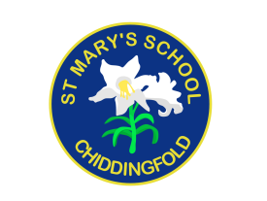

Parents/Carers Right to Reply slip

Is your Right to Reply comment for the School or PTA?

(Please delete as applicable)
School | PTA

Please use the space below or overleaf, or email admin2@stmarys-godalming.surrey.sch.uk to notify us of anything you wish to discuss:
Name
Child/ren’s class/es
Date

