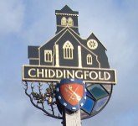
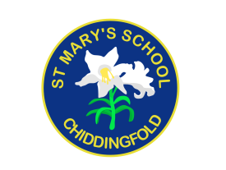
St Mary’s Church of England Primary School
an academy in the Good Shepherd Trust
Petworth Road, Chiddingfold, Surrey, GU8 4UF

Headteacher: Mrs Sheila Buckley

(t) 01428 683115 (e) admin2@stmarys-godalming.surrey.sch.uk (w) www.stmaryschidd.org
Respect, Wisdom, Hope, Community
18th January 2023

Dear Parents,

RE: Portals to the Past KS2 Ancient Egyptians Workshop

This term, Year 4 are studying the Ancient Egyptians. To further enhance the children’s topic learning, we have booked a fun, absorbing and interactive workshop that promises to introduce children to the fascinating and enigmatic world of the Ancient Egyptians. The workshop will take place at school on Monday 13th March 2023.

Throughout the day, the children will participate in activities as they learn about what happens following the death of a mighty Pharaoh, including tomb building, the mummification process, burial ceremonies and, finally, the crowning of the new Pharaoh. The day will also include doing basic maths the Egyptian way, and learning how to measure in cubits; discovering fascinating facts during an Egyptian-themed quiz; playing ‘Hounds and Jackals’ – an easy Egyptian board game; and exploring Egyptian artefacts and way of life.

The children are invited to dress up for the workshop, either as Egyptologists or Ancient Egyptians. They could re-use their costumes from the class assembly!

We invite you to make a voluntary contribution towards this workshop of £6.40 per child, which can be paid on Scopay by Friday 24th February 2023. If you are unable to contribute for any reason, please speak to Mrs Buckley in confidence. If we do not receive enough contributions towards the cost of the workshop, we will inevitably have to cancel. Please note that payment in Scopay acts as your consent for your child to take part.

Yours sincerely,

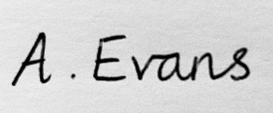
Mrs Alison Evans
Year 4 Class Teacher

