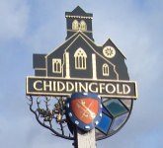
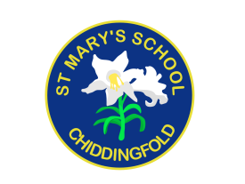
St Mary’s Church of England Primary School
an academy in the Good Shepherd Trust
Petworth Road, Chiddingfold, Surrey, GU8 4UF

Headteacher: Mrs Sheila Buckley

(t) 01428 683115 (e) admin2@stmarys-godalming.surrey.sch.uk (w) www.stmaryschidd.org
Respect, Wisdom, Hope, Community

12th July 2022

Dear Parents and Carers

RE: YEAR 5 RESIDENTIAL 2023

We are pleased and excited to say that following the tremendous success of previous residential visits to High Ashurst Outdoor Education Centre on Boxhill near Dorking, places have now been booked for next year.

The trip will take place from Wednesday 21st June – Friday 23rd June 2023.

We have endeavoured to keep costs down by choosing a reasonably priced centre that is also relatively close to home so that parents can assist with transport, rather than incur the added expense of coach travel.

The total cost of the trip will be £212.85 per child. This includes two nights’ full board and morning and afternoon activities supervised by fully qualified instructors.

If you would like to find out more information about the centre at High Ashurst and see why we have chosen it, please go to the Surrey Outdoor Learning & Development (SOLD) website at www.surreycc.gov.uk/outdoorlearning. SOLD has many years of experience providing outdoor and adventurous activities and field studies to a wide range of schools and we are confident our stay will benefit the children tremendously. The aim of our trip is to increase the children’s social awareness and interaction skills, develop their independence and also encourage them to problem solve and work as a team. The activity timetable will be provided nearer the time however, some of the available options include: climbing, abseiling, high ropes, archery and a challenge course. There is plenty of fun to be had!

The children will be staying in two of the onsite log cabins. We have chosen to opt for ‘catered camping’ and so main meals (breakfast and evening meal) will be taken in the Grand Hall and the two packed lunches which are provided can be eaten between activities. We will hold an after school meeting in the spring term to provide further information on timings, travel arrangements and to provide a full kit list.

In order for us to confirm the booking for your child, we request that you pay in Scopay a non-refundable first deposit of £32.85 by 30th September 2022. If you would then like to continue to pay in instalments, you can do so on Scopay. The attached instalment payment deadlines will need to be met but if you would prefer to pay in full, then you may do so. Please note, payment of your deposit in Scopay will act as your consent for your child to go on this trip.

If you have, or anticipate, any financial difficulties regarding the trip please contact us in confidence as soon as possible so that we can discuss the options available. We would not wish any child to miss this extremely worthwhile and educational opportunity purely through lack of finance.

Please do not hesitate to ask either of us if you have any questions or queries regarding the above.

Yours sincerely,

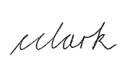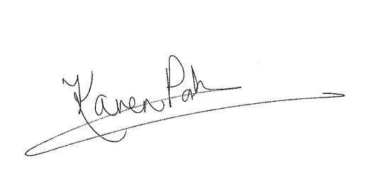

Christie Clark Karen Porter
Year 5 Class Teacher Year 5 Class Teacher

