Charging & Remissions Policy

Date | Review Date | Responsible Person | Responsible Body
October 2022 | October 2024 | Head teacher | GST

This School is committed to safeguarding and promoting the welfare of children and young people and expects all staff, governors and volunteers to share this commitment.

Statement of intent
This document is a statement of the aims, principles and strategies used for charging parents at St Mary’s Church of England Primary School.

Purpose
The purpose of the policy is to ensure that, during the school day, all children have full and free access to a broad and balanced curriculum. The school day is defined as 8.30am – 3.00pm.

This policy complements the school’s Equality Policy and Teaching & Learning Policy.

Roles and Responsibilities of head teacher, other staff and governors

The Head Teacher will ensure the following applies:

During the School Day
All activities that are a necessary part of the School Curriculum, including Religious Education will be provided free of charge. This includes any materials, equipment and transport to take pupils between the school and the activity (for example from school to the church). It excludes charges made for vocal or instrumental tuition for an individual pupil or a group, where these services are provided by visiting peripatetic teachers.

Voluntary contributions may be sought for activities, during the school day, which entail additional costs, for example, swimming, special activities involving high cost materials, trips involving traveling to another venue or visitors to school who provide a service.

In these circumstances, no pupil will be prevented from participating because his/her parents cannot or will not make a contribution. However, if the viability of the trip is dependent on voluntary contributions, parents will be informed of this from the outset.

Optional activities outside of the school day
We will charge for Breakfast Club and After School Care as these are optional, extra acre facilities, provided outside of the school day. Such activities are not part of the School Curriculum or Religious Education, nor are they part of an examination syllabus.
Where the school employs an external provider (including for After Care), or where there are additional costs, for examples, for cookery ingredients for a cookery club, then a charge will be made.

Education partly during the school day
If a non-residential activity happens partly inside the school day and partly outside of it, there will be no charge if most of the time to be spent on the activity falls within the school day. This includes, for example, Bedtime Stories evening, which is part of the literacy curriculum. Conversely, if the bigger proportion of time spent falls outside of the normal school day, charges will be made. When such activities are arranged parents will be told how the charges were calculated.

Calculating charges
When charges are made for any activity, whether during or outside of the school day, they will be based on the actual costs incurred, divided by the total number of pupils participating. There will
be no levy on those who can pay to support those who cannot. Support for cases of hardship will come through voluntary contributions, Pupil Premium Funding, bursaries (where available from outside educational providers) and fundraising.

Parents who would qualify for support are those who meet the free school meal eligibility criteria.

In line with the Good Shepherd Trust a 5% charge will be added to cover the online payments charges for using World Pay.

The principles of best value will be applied, when planning activities that incur costs to the school and/or charges to parents.

Arrangements for monitoring and evaluation
The governing body will monitor the impact of this policy by receiving financial reports on those activities that resulted in charges being levied, the subsidies awarded (without giving names) and the source of the subsidies. This information will be reported and reviewed annually.

Headteacher: | 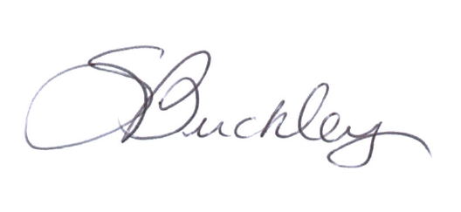 | Date: | Sept 2022
Chair of LGC: | 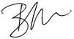 | Date: | Sept 2022

