St Mary’s C of E Primary School – an academy in the Good Shepherd Trust
Behaviour Policy Principles & Behaviour for Learning
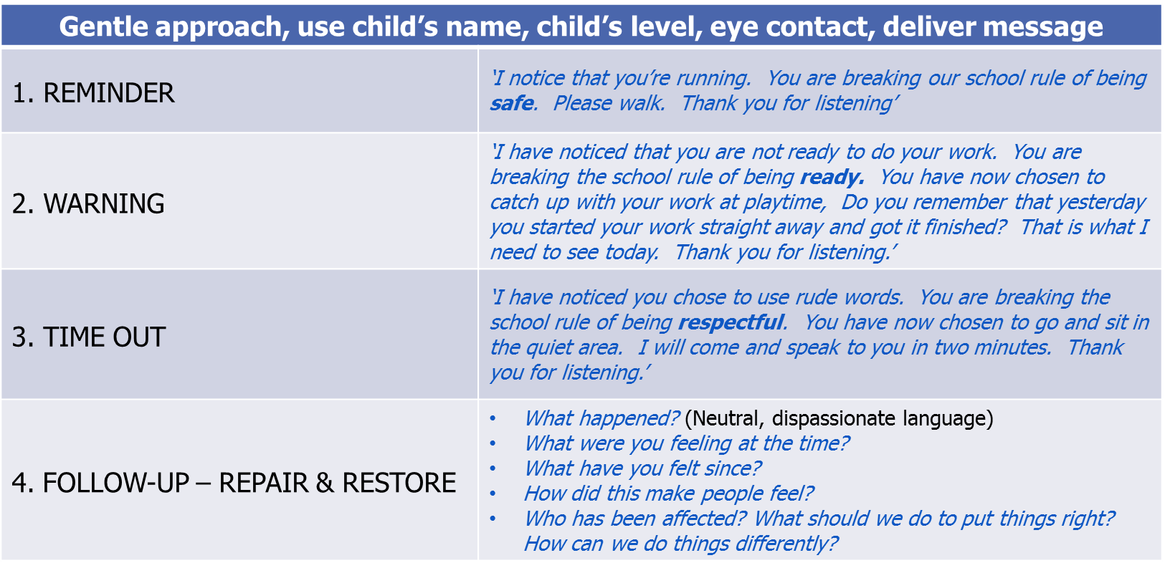
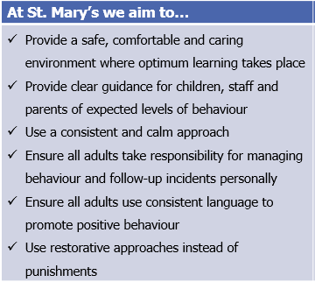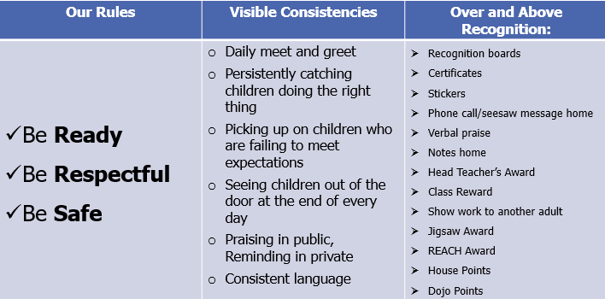
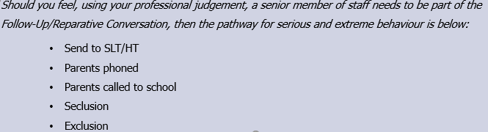
Behaviour Pathway
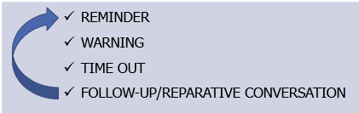

Recording behaviour incidents: Pupil incident forms, CPOMs

